Empathy Mapping - Understanding Your Customers' Thoughts and Feelings
Use Empathy Mapping to create happy customers.
Empathy is the ability to relate to the emotions of others. It's an essential workplace skill.
If you can empathize with other people, they'll likely respond in kind, making it easier to cooperate, collaborate and work as a team.
Potential customers, peripheral stakeholders, remote workers – sometimes it isn't easy to put yourself in the shoes of people you rarely encounter.
Empathy Mapping is a way to get closer to what these people think and feel about your product, service or situation. This article outlines a seven-step process for creating your Empathy Map.
What Is an Empathy Map?
Empathy Mapping was developed by Dave Gray, co-founder of strategy consultants XPlane. [1] It's a powerful visualization tool designed to help teams use Emotional Intelligence to gain insight into a target group.
The tool provides a series of prompts to identify a target group's thoughts, feelings, motivations, desires, and needs. This forces the investigating team to focus on the target group's requirements rather than its own.
A product development team, for instance, could use an Empathy Map to consider how people might respond to a new device or a pain point. A team manager might use one to assess their team's reaction to a new workflow.
Empathy Maps are highly visual, so it's easy to share them and pinpoint any gaps in knowledge or contradictions in research. Armed with this information, teams can deliver more effective solutions or develop products that are more in tune with customer expectations.
You can develop Empathy Maps in team sessions using a framework "canvas." Figure 1 shows what a blank Empathy Map canvas looks like.
Figure 1: a Blank Empathy Map Canvas
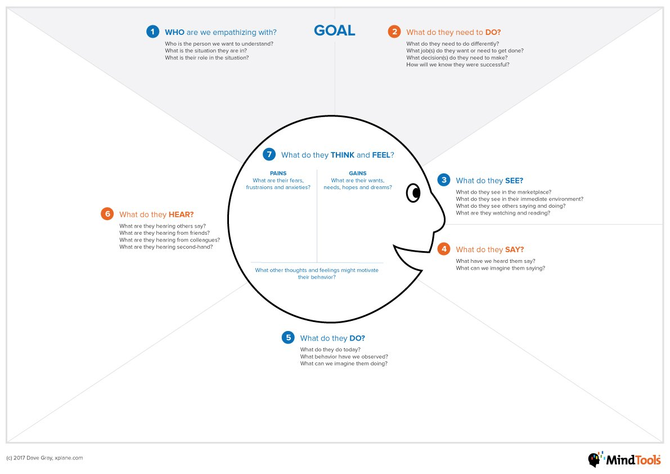
© 2017 Dave Gray, xplane.com.
Tip:
Empathy Maps are great for investigating behaviour at single moments or over periods. But you can also use them to understand how customers have behaved in the past and to predict how they might act in the future.
How to Build Your Empathy Map
Empathy Mapping is a collaborative exercise, so get everyone involved in the same room. Have plenty of sticky notes and marker pens available so that you can all get involved.
If you're working with a larger team, use a whiteboard with a large, blank Empathy Map stuck or drawn onto it. If it's a minor team, print out a sheet and have everyone annotate it, making sure that you leave enough space in the critical parts of the diagram.
Now, you and your team are ready to create an Empathy Map! The following seven steps will walk you through the process.
Note:
Your team needs to complete steps one and two in advance. So make sure you plan. Once they're finished, the remaining exercise should take no longer than 20 minutes.
(Download a template here to start creating your Empathy Map.)
1. Decide on the Subject and the Scope of Your Empathy Map
Your first step is to make two critical decisions:
- Who are you mapping? You might be mapping a test group of customers or a client who wants a new app designed, for example. You may like to represent these target groups using a persona – a fictional archetype of a customer or stakeholder. (Read our article, Developing Personas, for more information about this.)
- What is your main goal? What is it that your Empathy Mapping session needs to do or achieve? Your answer will set the direction for the rest of the mapping process. It may be helpful to use Customer Experience Mapping to pinpoint specific "touchpoints" that you want to address. Record it here if the stakeholder has asked a specific question about the situation you're investigating or has made a particular request.
2. Collect Relevant Data
Empathy Mapping works best if it's based on its subjects' actual thoughts, feelings, and perceptions.
So, as part of your development process, you should collect a range of data on your stakeholders' experiences.
These may come from subject interviews, surveys, observation, or listening to recorded sales calls. Be curious, and use the proper Questioning Techniques to draw out the information you need.
If you're doing face-to-face interviews, remember to listen actively, pay attention to nonverbal cues, and pick up better thoughts and feelings.
If you cannot directly interview your subjects, Market Segmentation techniques can help you define your target group and its needs.
Make sure that everyone involved in the mapping exercise reads the data in advance and understands the subject and the scope of the investigation.
3. Start to Fill in the Map
Now that you've taken the preliminary steps, you and your team can start to work on your Empathy Map.
Start with the "What do they SEE?" section (step three) on the right of the map. Think through the subsidiary questions here, and always base your responses on research and feedback you've gathered. These questions include:
- What do they see in the marketplace?
- What do they see in their immediate environment?
- What do they see others saying and doing?
- What are they watching and reading?
If possible, everyone in the team should add at least one comment to the section. You can write answers on sticky notes and stick them on the central board. Or, if your team is divided into smaller groups, write directly on the group map.
4. Complete the Outer Sections of the Map
Moving clockwise around the map, repeat what you've done in step three for steps four, five and six.
Be guided in each case by the subsidiary questions. As far as possible, use language that the subjects themselves would use, and try not to summarize or interpret.
5. Complete the Center Section of the Map
Once you've completed the circuit of "outer" elements on the canvas, it's time to move "inside" your customers' heads.
This is the crucial part of the Empathy Mapping exercise. Understanding your customers' thoughts and feelings is the foundation for empathizing with them, so make sure you have plenty of space to write in the centre.
Divide their thoughts and feelings into "pains and gains." Pains are things that worry, frustrate or anger them. Gains are what they want, need or hope for.
Take information from your research in step one and refine it. What does it show that your stakeholders are thinking and feeling? Get your team to think from the customer's perspective.
6. Reflect on What You've Discovered
Now, you and your team can take a step back and review what you've come up with.
If possible, ask other colleagues to review and "sense check" what you've created and offer their thoughts and suggestions.
7. Draw Conclusions and Take Action
At the centre of your map, you now have a clear picture of how your stakeholders or customers feel about their situation or what they need.
This is the basis for a plan of Action that puts empathy and emotional intelligence at the centre of the process.
Your next step could be to create a value proposition for the product you're developing or the situation you're addressing. You could also use Empathy Mapping to help you deliver user-centred solutions as part of the first stage in Design Thinking.
Empathy Maps are a great way to give you confidence in your solutions, products or services. By "stepping into the shoes" of your customers, you can ensure that their needs and desires are fully being taken into account.
Key Points
Empathy Mapping is a team process that helps you identify a particular group's thoughts and feelings – usually customers – on a specific issue.
It does this by making you look at the issue through their eyes and empathizing with their feelings. When refining or developing products or services, it is usually used to achieve a satisfactory outcome on the users' behalf.
You can create your Empathy Map using the downloadable worksheet attached to this article and by following these seven steps:
- Decide on the subject and scope of your Empathy Map.
- Collect relevant data.
- Start to fill in the map.
- Complete the outer sections of the map.
- Complete the centre section of the map.
- Reflect on what you've discovered.
- Conclude and take Action.

